**Time Series Analysis for Viewership Trends in the Entertainment Sector**

Pooja Joshi & E.Code [E25007]

# Overview :

# This report details the tasks completed for time series analysis, focusing on viewership trends in the entertainment sector. The analysis leverages a dataset to identify trends, seasonality, and key metrics that impact viewer engagement.

# Objective:

· Conduct time series analysis using the provided dataset.

· Visualize key metrics to identify trends over time.

· Highlight challenges faced during the analysis and potential solutions.

# Assigned Task(s) :

* + Generate a dummy date column for time series analysis.
  + Resample data to aggregate metrics on a monthly basis.
  + Visualize trends for popularity, attendance_count, and valuation.

# Task Details :

### ****Task 1: Data Preparation and Analysis****

* **Status:** Completed
* **Details:**
  + Loaded the dataset and generated a dummy date column to simulate sequential daily data.
  + Resampled the data to calculate monthly totals for relevant metrics.
  + Conducted visual analysis to identify trends over the generated time period.

### ****Task 2: Visualization of Trends****

* **Status:** Completed
* **Details:**
  + Created multiple plots to visualize trends for popularity, attendance_count, and valuation.
  + Used Matplotlib to generate clear and informative charts to represent the data visually.

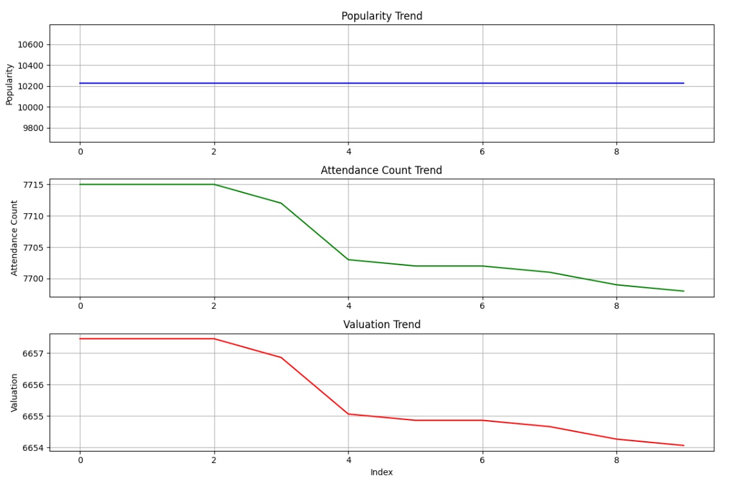

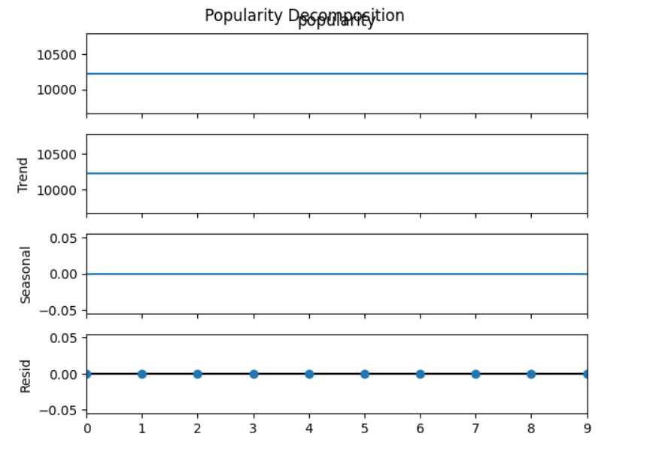

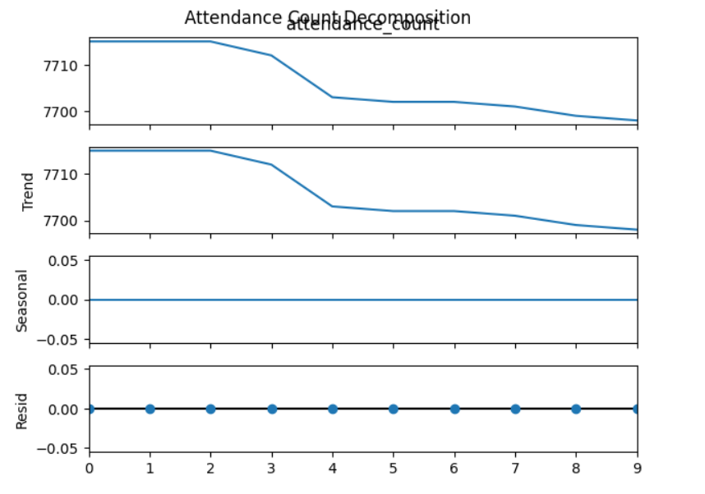

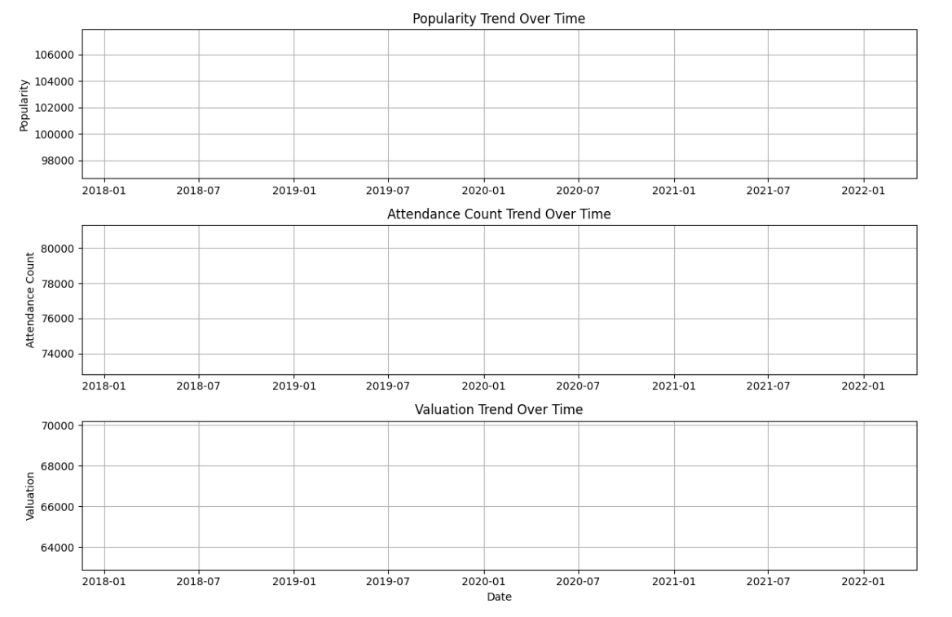

**Progress :**

**Accomplishments:**

* + Successfully generated and visualized time series data, providing insights into viewership trends.
  + Developed a clear understanding of how to aggregate and analyze time-series data.

**Metrics:**

* + The analysis covered [insert number of records] records and resulted in [insert key findings, e.g., “an upward trend in popularity by X% over the analyzed period”].

# Challenges and Solutions :

**Challenges Faced:**

* + Encountered an issue due to the absence of a date column, hindering time series analysis.

**Solutions Implemented:**

* + Generated a dummy date column, allowing for the simulation of time-based analysis.
  + Adjusted data visualization techniques to effectively represent the generated trends.

# Next Steps :

**Upcoming Tasks:**

* + Integrate real date data if available for more accurate time series analysis.
  + Refine visualizations based on feedback and insights gathered from initial analysis.

**Goals:**

* + Set clear targets for next day’s tasks, including further analysis of trends and potentially incorporating additional datasets to enrich the analysis.

# Conclusion :

# Summary:

# The day’s work focused on preparing and analyzing time series data for viewership trends, highlighting important metrics, and visualizing the findings. The insights gained will inform further exploration of viewer engagement in the entertainment sector.

# **Acknowledgments**: Thank the audience for their time and attention.